1. Select Your Operating System (OS): Choose an operating system that best suits your preferences and project requirements. Download and Install Windows 11. <https://www.microsoft.com/software-download/windows11>

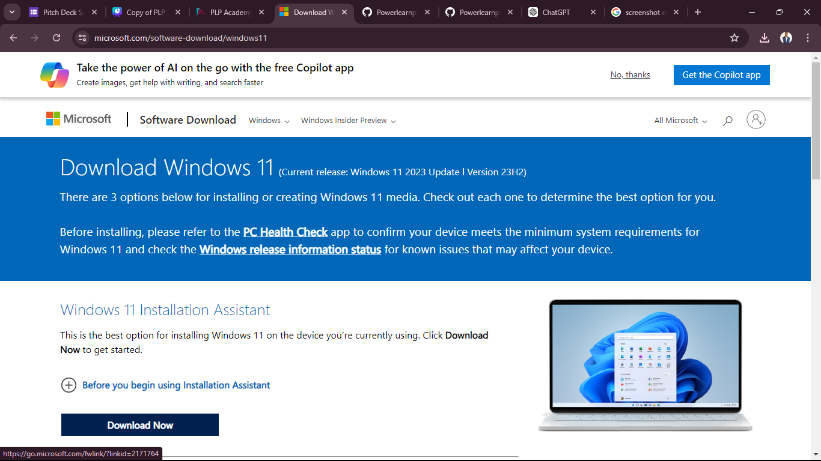

1. Install a Text Editor or Integrated Development Environment (IDE): Select and install a text editor or IDE suitable for your programming languages and workflow. Download and Install Visual Studio Code. <https://code.visualstudio.com/Download>

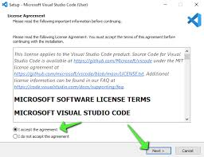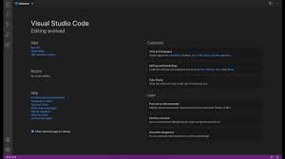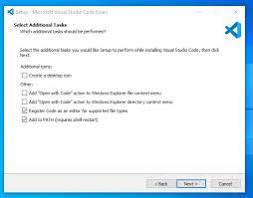

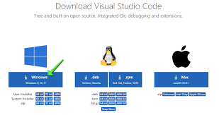

1. Set Up Version Control System: Install Git and configure it on your local machine. Create a GitHub account for hosting your repositories. Initialize a Git repository for your project and make your first commit. [https://github.com](https://github.com/)

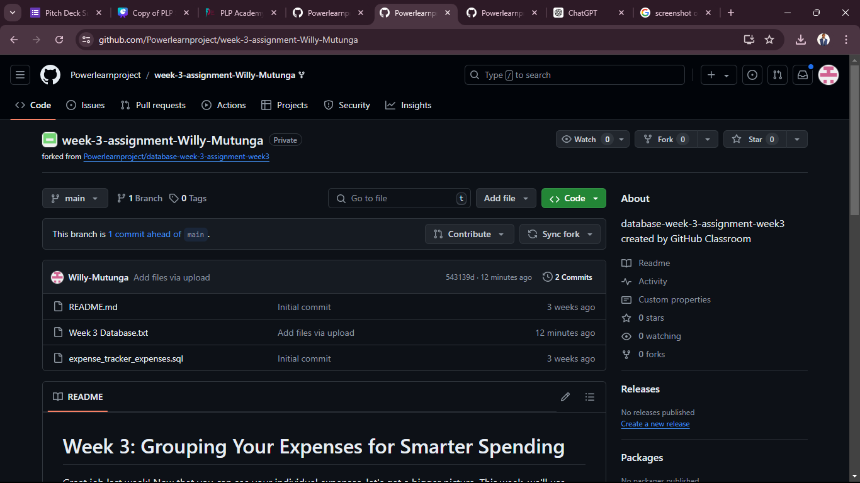

1. Documentation on Installation

• **Download VS Code Installer**:

* Visit the official Visual Studio Code website: [VS Code Download](https://code.visualstudio.com/Download).
* Download the installer suitable for your operating system (Windows, macOS, Linux).

• **Install VS Code**:

* Run the downloaded installer.
* Follow the on-screen instructions to install VS Code on your system.
* If you encounter any prompts during installation (such as granting administrative privileges), follow them accordingly.

• **Open VS Code**:

* After installation, launch VS Code from the desktop shortcut or from the installed applications list.

• **Explore User Interface**:

* Familiarize yourself with the VS Code user interface, which typically includes a sidebar (for file navigation), editor area (for coding), and status bar (for notifications and settings).

• **Install Extensions**:

* VS Code's power lies in its extensions. Explore and install extensions that suit your programming needs (e.g., language support, debugging tools, Git integration).
* Navigate to the Extensions view in the sidebar (or press Ctrl+Shift+X).
* Search for extensions by name or functionality, then click "Install" to add them to VS Code.

• **Configure Settings**:

* Customize VS Code settings to tailor the editor to your preferences.
* Access settings by clicking on the gear icon in the bottom left corner (File > Preferences > Settings on Windows/Linux or Code > Preferences > Settings on macOS).
* Modify settings either directly in the UI or by editing settings.json (accessible via Open Settings (JSON) link).

• **Integrate with Version Control**:

* If using Git for version control, ensure Git is installed on your system.
* Install the Git extension in VS Code (Ctrl+Shift+X, search for "Git").
* Configure VS Code to use Git by setting up your name and email (git config --global user.name "Your Name" and git config --global user.email "your.email@example.com").

• **Set Up Debugging** (if applicable):

* VS Code supports debugging for various programming languages.
* Install debugging extensions if necessary (Ctrl+Shift+X, search for "debugger" or specific language debuggers).
* Configure launch configurations (launch.json) for your project to specify how to launch and debug your application.

• **Explore Additional Features**:

* VS Code offers a wide range of features beyond basic editing and debugging.
* Explore functionalities such as integrated terminal (Ctrl+ `), task automation (tasks.json), and workspace management.

• **Learn Keyboard Shortcuts**:

* Mastering keyboard shortcuts can significantly improve productivity.
* Review and practice commonly used shortcuts in VS Code (Ctrl+K Ctrl+S to open Keyboard Shortcuts reference).

• **Join the VS Code Community**:

* Stay updated with new features, extensions, and tips by joining the VS Code community.
* Follow official VS Code channels, participate in forums (e.g., Stack Overflow), and engage in discussions with other developers.

• **Update VS Code Regularly**:

* VS Code receives frequent updates with bug fixes and new features.
* Check for updates periodically (Help > Check for Updates) and install them to ensure you have the latest improvements.